COSC Team Proposed Solution:

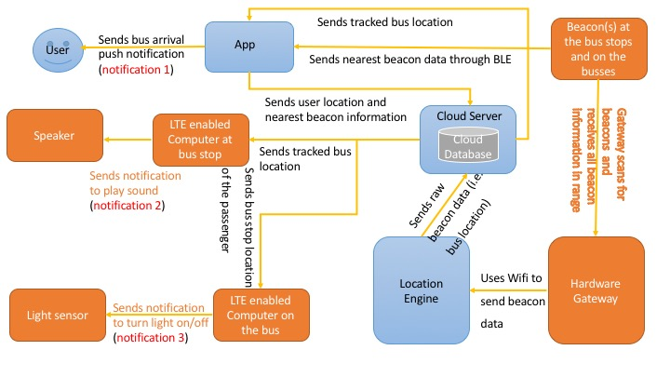

Note: EE team is responsible for the orange parts including receiving data from the server as that is part of small board computer programming. COSC team is responsible for the rest and the server side will do most of the heavy lifting computations.

Pros:

1. Data is going to the end user (app/computers) directly from the server through internet. User’s phone not being the middle man means more battery and internet saving for the user.
2. COSC team knows how to pass data from the server to the computers using internet. We will use industry standard REST API that can be used for iOS or any other platforms as well. COSC team can also guide EE team on how to receive the data from the server, means less development time for both teams and can guarantee a successful project if everything goes well.
3. No extra BLE or GPS modules required. Client saves more money.
4. Minimum API calls made to the server side, means less variable cost.

Cons:

1. LTE modules required for computers on the bus stop and bus both. More fixed cost for the client.

Alternative Solution: Not using beacons at all. Just rely on GPS to get bus location.

Alternative solution 1:

A screenshot of a cell phone


Alternative solution 2 (EE team preferred):

A screenshot of a cell phone

